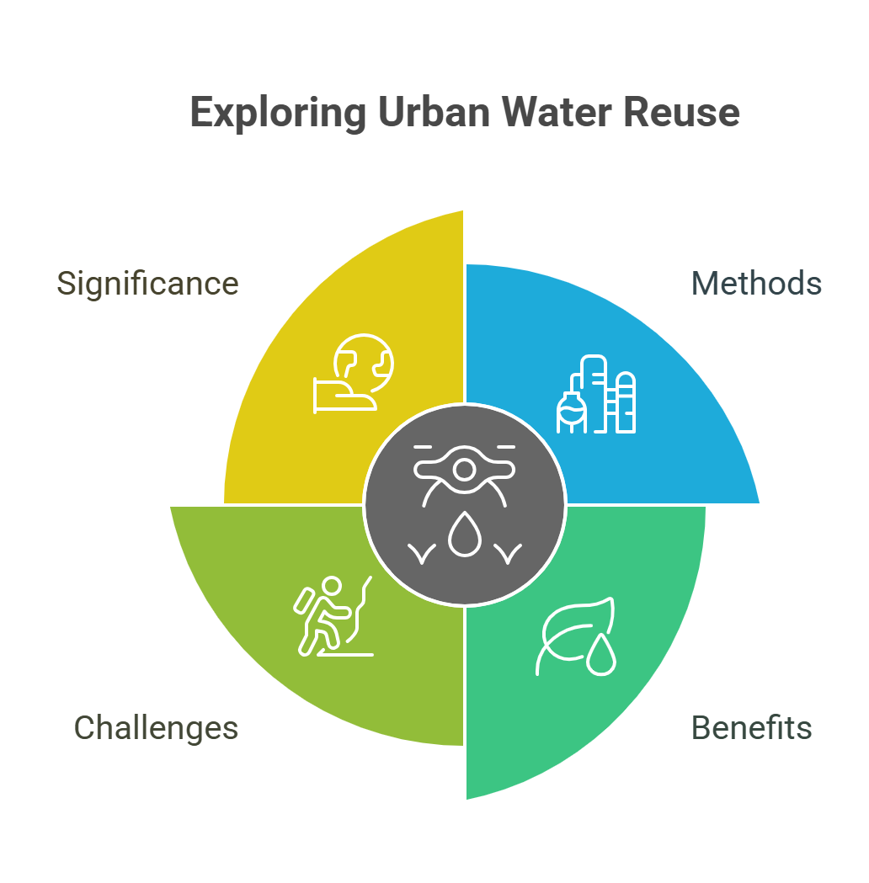

**Urban Water Reuse**

Urban water reuse is an innovative approach to managing water resources in cities, aimed at addressing the growing challenges of water scarcity and environmental sustainability. This document explores the various methods, benefits, and challenges associated with urban water reuse, highlighting its significance in promoting sustainable urban development and enhancing water security.

**Introduction**

Urban areas are facing increasing pressure on their water resources due to population growth, industrial demands, and climate change. Water reuse presents a viable solution to mitigate these challenges by recycling wastewater for various applications, thereby conserving freshwater resources and reducing environmental impacts. This document delves into the different types of urban water reuse, including direct and indirect reuse, and examines their applications in irrigation, industrial processes, and potable water supply.

**Types of Urban Water Reuse**

1. **Direct Reuse**: This involves the immediate use of treated wastewater for non-potable applications, such as irrigation, toilet flushing, and industrial processes. Direct reuse systems require advanced treatment technologies to ensure the safety and quality of the water.
2. **Indirect Reuse**: In this method, treated wastewater is discharged into natural water bodies, such as rivers or aquifers, where it undergoes further natural treatment processes before being extracted for use. Indirect reuse is often used for potable water supply, as it allows for additional purification through natural filtration.

**Benefits of Urban Water Reuse**

* **Water Conservation**: Reusing water significantly reduces the demand for freshwater sources, helping to conserve valuable water resources.
* **Environmental Protection**: By treating and reusing wastewater, urban water reuse minimizes the discharge of pollutants into natural water bodies, protecting ecosystems and biodiversity.
* **Cost-Effectiveness**: Implementing water reuse systems can be more economical than developing new water supply sources, particularly in water-scarce regions.
* **Resilience to Climate Change**: Urban water reuse enhances the resilience of cities to climate variability by diversifying water supply sources and reducing reliance on traditional freshwater supplies.

**Challenges of Urban Water Reuse**

Despite its numerous benefits, urban water reuse faces several challenges:

* **Public Perception**: There is often a stigma associated with using recycled wastewater, particularly for potable applications. Public education and outreach are essential to build trust and acceptance.
* **Regulatory Framework**: The lack of comprehensive regulations and guidelines for water reuse can hinder its implementation. Establishing clear standards is crucial for ensuring safety and quality.
* **Technical and Infrastructure Barriers**: Developing the necessary infrastructure for water treatment and distribution can be costly and complex, requiring significant investment and planning.

**Conclusion**

Urban water reuse is a critical strategy for sustainable water management in cities, offering a pathway to address water scarcity and environmental challenges. By embracing innovative technologies and fostering public acceptance, urban areas can effectively implement water reuse practices, contributing to a more sustainable and resilient future. As cities continue to grow, the importance of urban water reuse will only increase, making it an essential component of urban planning and development.